Name: | ___________________________________________________ |  |  |  |  | Date: ___________
 | Year 10 Maths Extension/General  Investigation 2, 2013  Topic - Linear Functions  In class component |  |  |  |  | 36  = %
Total Time: | 60 minutes
Reading Time: | 5 minutes
Working Time: | 55 minutes
Weighting: | 8% of the year.
Equipment: | Scientific Calculator
Date out: |  | Week ____ Date _____________ |  | Date Due: | Week ____ Date _____________
Take home component weighting: |  | 0% of the year |  | In-class component weighting: | 8% of the year.
AIM: In this assessment, you will be investigating linear functions, in particular:
- drawing their graphs from their equations
- deriving their equations from their graphs and
- deriving their equations from tables of values

1. | [12 marks: 3, 3, 3, 3]
 | Graph the following lines on the axes provided:
a) | y = 2x - 3  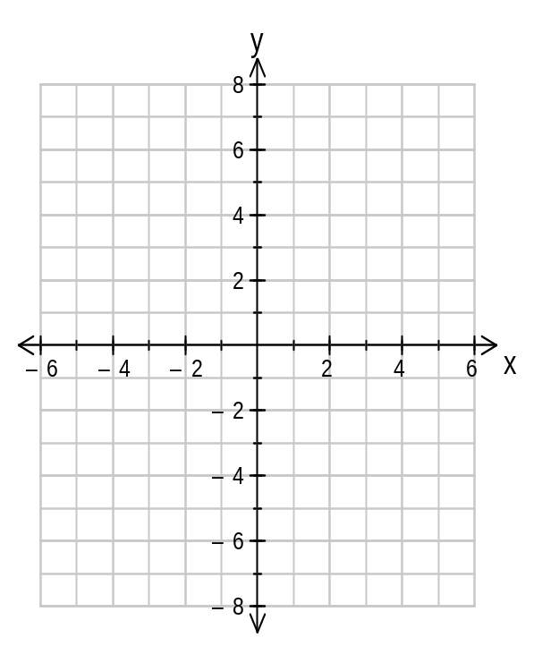 | b) | y = 5 - 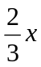
c) | 3x + y = 6 | d) | 4x – 3y = 12

2. | [6 marks: 2, 2, 2]
 | Give the equations of the three lines in the graph on the right
a) | Line A  y = ____________________ | 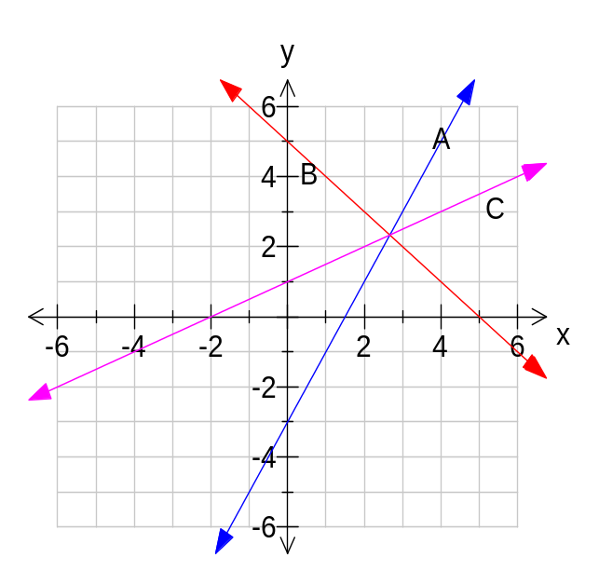
b) | Line B  y = ____________________
c) | Line C  y = ____________________

3. | [6 marks: 2, 2, 2]
 | Give the equations of the three lines in the graph on the right
a) | Line A  y = ____________________ | 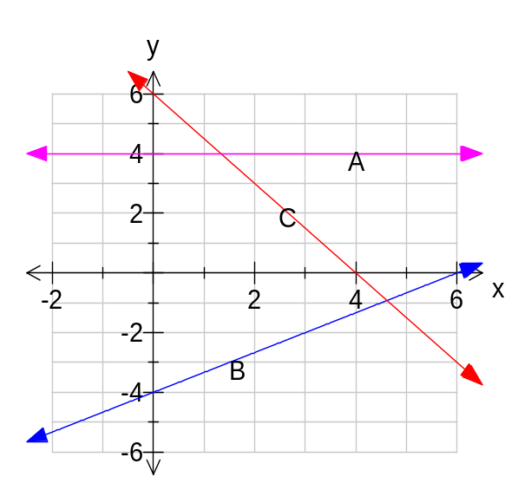
b) | Line B  y = ____________________
c) | Line C  y = ____________________

4. | [12 marks: 2, 2, 2, 2, 2, 2]
 | For each of the linear functions defined by the tables below, state the equation:-
a) | Equation is y = ____________
  x | 0 |  | 1 |  | 2 |  | 3 |  | 4 |  | 5 |  | 6
  y | 6 |  | 10 |  | 14 |  | 18 |  | 22 |  | 26 |  | 30
  First difference
b) | Equation is y = ____________
  x | 0 |  | 1 |  | 2 |  | 3 |  | 4 |  | 5 |  | 6
  y | 15 |  | 12 |  | 9 |  | 6 |  | 3 |  | 0 |  | -3
  First difference
c) | Equation is y = ____________
  x | 0 |  | 1 |  | 2 |  | 3 |  | 4 |  | 5 |  | 6
  y |  |  | 16 |  | 25 |  | 34 |  | 43 |  | 52 |  | 61
  First difference
d) | Equation is y = ____________
  x | 0 |  | 2 |  | 4 |  | 6 |  | 8 |  | 10 |  | 12
  y |  |  | -3 |  | 4 |  | 11 |  | 18 |  | 25 |  | 32
  First difference
e) | Equation is y = ____________
  x | 3 |  | 6 |  | 9 |  | 12 |  | 15 |  | 18
  y | 29 |  | 23 |  | 17 |  | 11 |  | 5 |  | -1
  First difference
f) | Equation is y = ____________
  x | 20 |  | 30 |  | 40 |  | 50 |  | 60 |  | 70 |  | 80
  y | 117 |  | 97 |  | 77 |  | 57 |  | 37 |  | 17 |  | -3
  First difference

